

|  |  |
| --- | --- |
| **Student Name** | **Arun Adhikari** |
| **SRN No** | 202100406 |
| **Roll No** | 38 |
| **Program** | Computer Engg. |
| **Year** | Third Year |
| **Division** | G |
| **Subject** | CN |
| **Assignment No** | 6 |

**Assignment Number - 06**

**Title :** Conﬁguration of router for implementation of Open Shortest Path First (OSPF) Protocol

Problem Statement Using a Network Simulator (e.g. packet tracer) Conﬁgure routers for OSPF routing

# Theory :

**OSPF Protocol**

OSPF is a complex routing protocol. It uses many terms to deﬁne its functions and operations.

# Link

A link is a router's interface connected to an IP subnet. When we add an interface to the OSPF process,

OSPF considers the interface as a link.

# State

Since a link is an interface, it has two states: up and down. The up state shows the link (interface) is

operational and OSPF can reach the IP subnet connected to the link. The down state shows the link is not

operational and OSPF cannot reach the IP subnet connected to the link.

# Link state protocol

OSPF is a link-state protocol. Link state protocols use the Shortest Path First (SPF) algorithm to calculate the best path to a destination. To run this algorithm, link-state protocols learn the complete topology of the network. In a big size network, this feature creates scalability problems. To solve this

problem, OSPF uses two concepts: autonomous systems and areas.

# An autonomous system

An autonomous system is a group of networks under a single administrative control which can be a group

of companies, a company, or a division within the company. There are two types of routing protocols:

Interior Gateway Protocol (IGP) and Border Gateway Protocol (BGP). IGP routing protocols provide routing within a single AS. BGP routing protocols provide routing between different AS. OSPF is a IGP routing protocol. OSPF provides routing within a single AS.

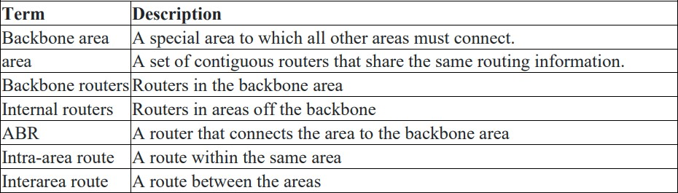

OSPF Area OSPF groups network together, where the topology of one group is hidden from the other. These set of groups are called Areas. An area ID is 32 bit number, which is unique identiﬁcation number that differentiates each area.

**Backbone area (Area 0)** – Responsible for distributing routing information among other areas of the system. The backbone area is identiﬁed by the number 0.0.0.0

**Off backbone area (Area 1-65535)** – consist of areas other than backbone area of system.

# Conﬁguration of OSPF

The systax for conﬁguring OSPF is:

Router(Conﬁg)#router ospf process_ID

Router(Conﬁg)#network Network_address Wildcard_mask area are_no

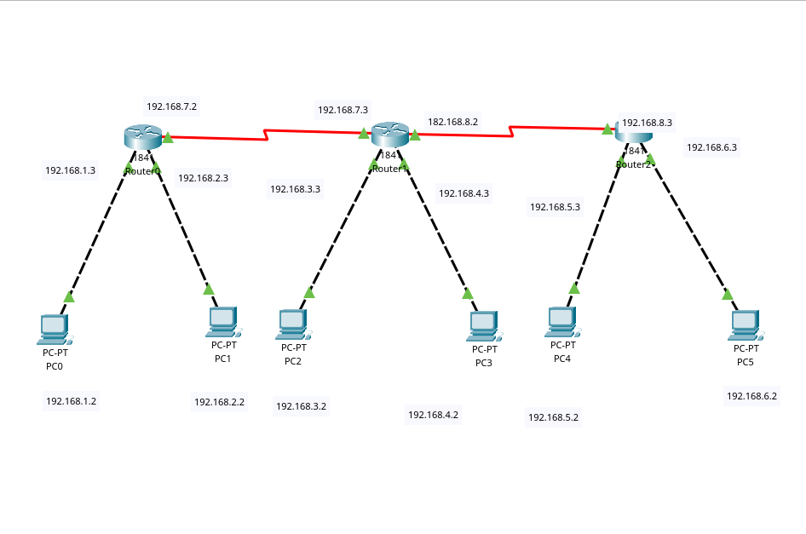

**Router 0 :**

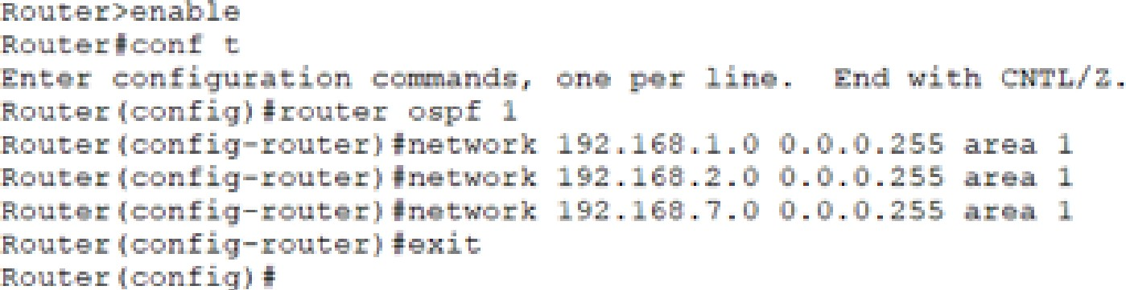

# Router 1:

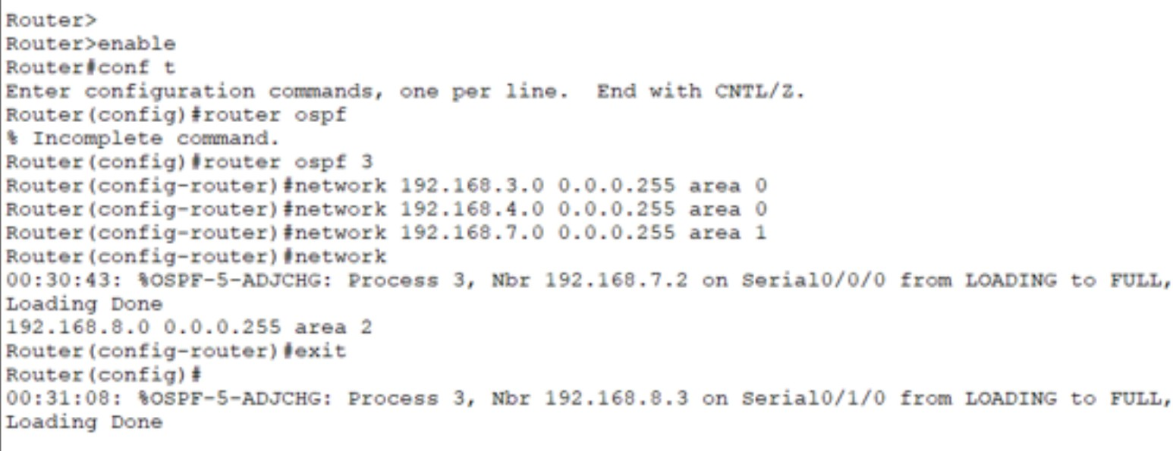

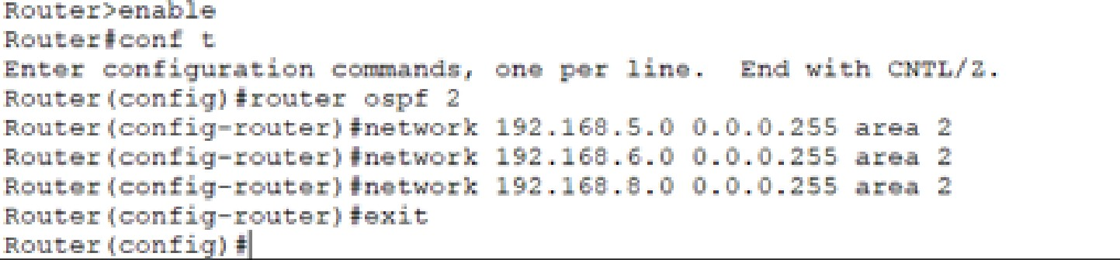

**Conclusion:**

The Open Shortest Path First (OSPF) protocol is recognized for its robust and scalable nature, making it suitable for a wide range of network

environments. OSPF relies on link-state information to construct a detailed and precise representation of the network's topology. It employs the Dijkstra algorithm to determine the shortest routes to destinations, factoring in various considerations such as cost. OSPF's hierarchical structure and support for network areas contribute to scalability and resource optimization. Conﬁguring OSPF involves deﬁning areas, assigning router IDs, and specifying networks. The protocol enables rapid adaptation to changes in network topology through the use of timers and triggers, ensuring eﬃcient convergence. Its support for variable-length subnet masks (VLSM) and IPv6 caters to modern networking needs. Despite its complexity, OSPF remains

the preferred choice for medium to large-scale networks, offering reliability, eﬃciency, and adaptability in dynamic routing.